Circuit diagram

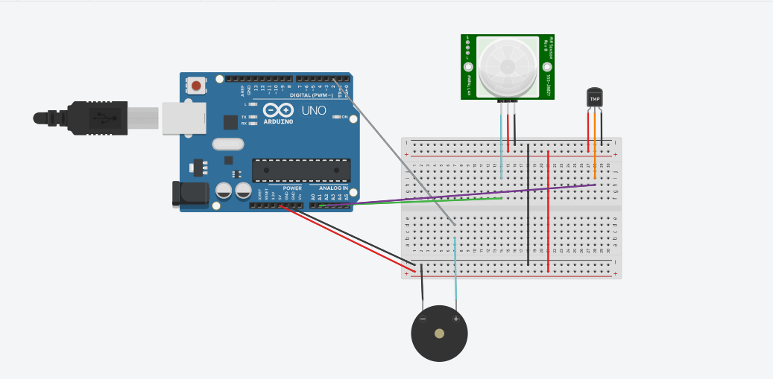

code

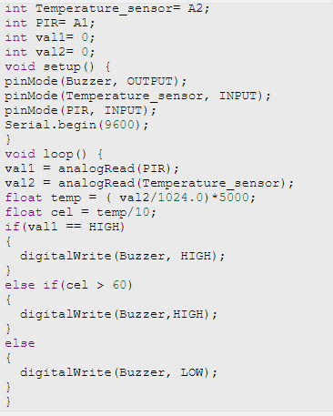

code

int Buzzer= 2;

int Temperature_sensor= A2;

int PIR= A1;

int val1= 0;

int val2= 0;

void setup() {

pinMode(Buzzer, OUTPUT);

pinMode(Temperature_sensor, INPUT);

pinMode(PIR, INPUT);

Serial.begin(9600);

}

void loop() {

val1 = analogRead(PIR);

val2 = analogRead(Temperature_sensor);

float temp = ( val2/1024.0)*5000;

float cel = temp/10;

if(val1 == HIGH)

{

digitalWrite(Buzzer, HIGH);

}

else if(cel > 60)

{

digitalWrite(Buzzer,HIGH);

}

else

{

digitalWrite(Buzzer, LOW);

}

}